**Name:.....................................................................stream:...............LIN:...................**

**STANDARD COLLEGE – BUGIRI**

**Uganda Certificate of Education.**

**Biology 553/1**

**Theory**

**Time: 2hours and 15 minutes**

**Instructions**

This paper consists of TWO sections A and B.

Section A comprises of 3 compulsory items and section B comprises of PART I and PART II with a total of 4 items.

Attempt **ALL** the items in **section A** and only **TWO** item in **section B** picking **one** from **each part.**

**SECTION A**

**Structured items.**

**Item 1**

Farmers in Naluwere are frustrated about the rampart attack of their maize plantations by some strange organisms. On several occasions, they find the maize crops fallen down and others hollow.

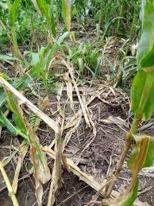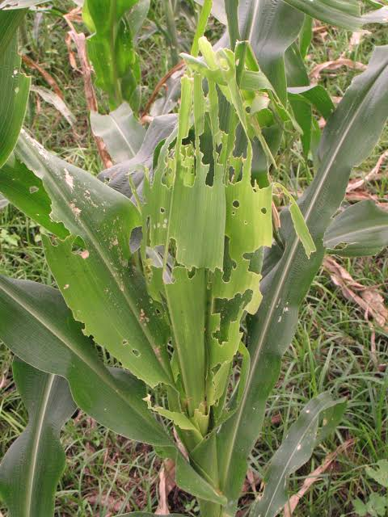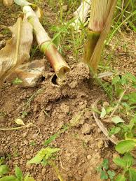The farmers are worried the yields may be poor. They seek intervention from the local government.

1. Suggest the organs of the maize plants that affected the invasion of the strange organisms.

...............................................................................................................................................................................................................................................................................................................................................

...............................................................................................................................................................................................................................................................................................................................................

1. Explain what would happen to the maize plant from the perspective of the organs affected

................................................................................................................................................................................................................................................................................................................................................

......................................................................................................................................................................................................................................................................................................................................................................................................................................................................................................................

................................................................................................................................................................................................................................................................................................................................................

......................................................................................................................................................................................................................................................................................................................................................................................................................................................................................................................

................................................................................................................................................................................................................................................................................................................................................

......................................................................................................................................................................................................................................................................................................................................................................................................................................................................................................................

................................................................................................................................................................................................................................................................................................................................................

......................................................................................................................................................................................................................................................................................................................................................................................................................................................................................................................

1. Suggest why it was a necessary for farmers to complain to the local government

................................................................................................................................................................................................................................................................................................................................................

......................................................................................................................................................................................................................................................................................................................................................................................................................................................................................................................

................................................................................................................................................................................................................................................................................................................................................

......................................................................................................................................................................................................................................................................................................................................................................................................................................................................................................................

**Item Two**

Plants use inorganic substances to make complex organic food compounds that are used up the plant body for various processes.

The inorganic substances include water from the soil and carbon dioxide from the atmosphere.

During a Biology lesson, the students were asked to discuss how plants are able to utilize inorganic substances to sustain their life requirements. Assuming you were among the lesson attendant, make a scientific write up for the context.

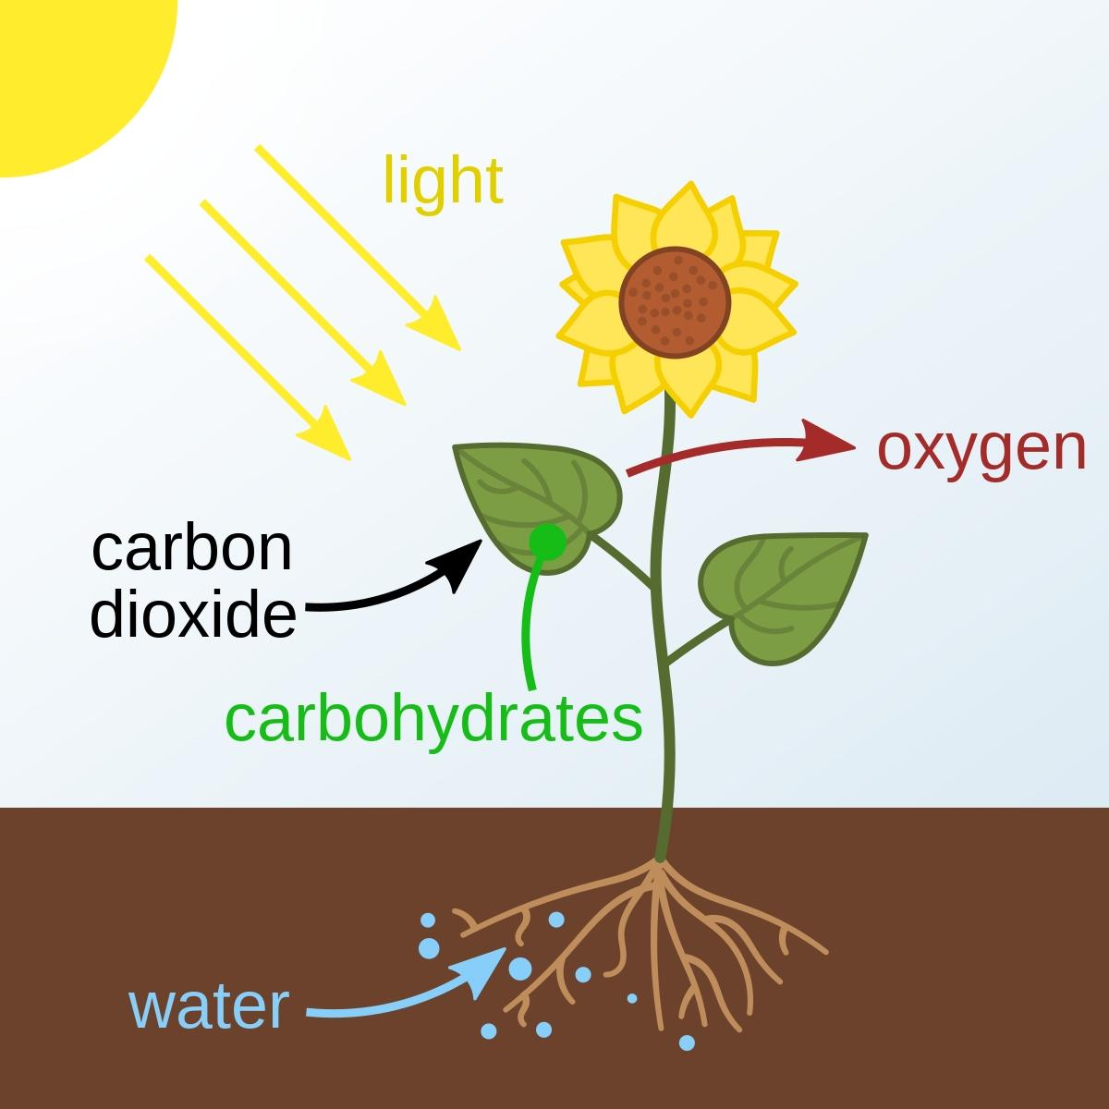

.......................................................................................................................................................................................

.......................................................................................................................................................................................

.......................................................................................................................................................................................

....................................................................................................................................................................................... .......................................................................................................................................................................................

.......................................................................................................................................................................................

.......................................................................................................................................................................................

.......................................................................................................................................................................................

.......................................................................................................................................................................................

.......................................................................................................................................................................................

.......................................................................................................................................................................................

....................................................................................................................................................................................... .......................................................................................................................................................................................

.......................................................................................................................................................................................

.......................................................................................................................................................................................

.......................................................................................................................................................................................

.......................................................................................................................................................................................

.......................................................................................................................................................................................

.......................................................................................................................................................................................

....................................................................................................................................................................................... .......................................................................................................................................................................................

.......................................................................................................................................................................................

.......................................................................................................................................................................................

.......................................................................................................................................................................................

.......................................................................................................................................................................................

......................................................................................................................................................................................

.......................................................................................................................................................................................

....................................................................................................................................................................................... .......................................................................................................................................................................................

.......................................................................................................................................................................................

.......................................................................................................................................................................................

.......................................................................................................................................................................................

**Item Three**

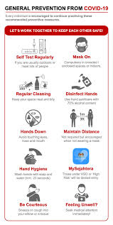In 2019, there global pandemic due to viral infection that raised socio-economic crisis world wide. There pandemic halted business, social interactions, education and entertainment. This situation was characterized by intensive fear and volunarable state of isolation that contributed to stress in human life.

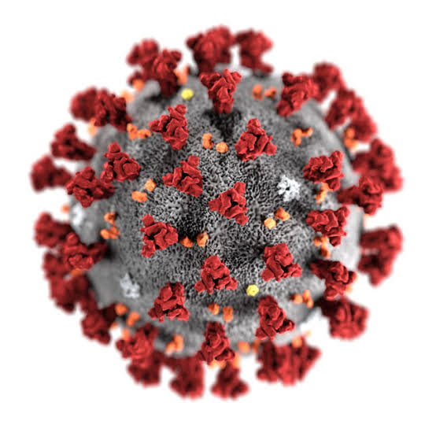

1. Identify the forms of stress that was experienced by humans during the recess and show how it came about in the family.

................................................................................................................................................................................................................................................................................................................................................

................................................................................................................................................................................................................................................................................................................................................

................................................................................................................................................................................................................................................................................................................................................

................................................................................................................................................................................................................................................................................................................................................

................................................................................................................................................................................................................................................................................................................................................

1. Suggest the appropriate procedures that were undertaken by humans to manage the stress identified

................................................................................................................................................................................................................................................................................................................................................

................................................................................................................................................................................................................................................................................................................................................

................................................................................................................................................................................................................................................................................................................................................

................................................................................................................................................................................................................................................................................................................................................

................................................................................................................................................................................................................................................................................................................................................

................................................................................................................................................................................................................................................................................................................................................

................................................................................................................................................................................................................................................................................................................................................

................................................................................................................................................................................................................................................................................................................................................

................................................................................................................................................................................................................................................................................................................................................

................................................................................................................................................................................................................................................................................................................................................

**SECTION B**

**PART I**

Attempt only one item from this part. Answers should be written from the answer booklet provided.

**Item Four**

In Bukatu community, the farmers are fond of using artificial fertilizers to improve on their crop productivity.

Currently the cost of these fertilizers is very high and they can nolonger manage to buy them and therefore their crop yields are always very poor. In the neighbouring community, the farmers are not affected since they disregarded the use of such fertilizers.

**Task**

Explain how the use of artificial fertilizers in Bukatu community have affected soil as a natural resource and hence point out how best they can appreciate the value of soil in their community.

**Item Five**

In Mukuba community in Bugiri district, most people carry out agricultural activities in the swamp claiming that the soils in the swamp are so fertile.

In rainy seasons the maize grown look pale yellow, dry up and no yields are realized at all.

The farmers are wondering what might be the problem yet there is abundance of water.

**Task**

Guide the farmers, explaining the cause of no yields in such rainy season and how best they can the soil as a natural resource sustainably.

**PART II**

Attempt only one item from this part. Answers should be written from the answer booklet provided.

**Item Six**

Human bodies require nutritional compounds for proper functionality.

Ouma was feeling weak in the morning from bed as he had not ate any meal at supper the previous night, he then consumed a meal of eggs, bread and milk during his beak fast after an hour, he began feeling relatively stronger. He became happy and commented to younger sibling “there is a secret in food"

Feeling very curious, the younger sibling demands to know the secret in food that his elder brother Ouma ate

**Task**

Explain how the food Ouma ate was bought into the general body function.

**Item seven**

In some plant species water offers structural support. William a young botanist took a study on weak stem plants (case study on the black jack). He observed that during the rainy season, the black jack plants would look health and erect but in sunny season, the plants looked bent and wilted.

He remained confused and failed to the cause of this magic in the plant system.

**Task**

Explain to William the causes of the events that occurred in the black jack plant system during the different weather conditions.

*Sucess wishes*